**Intensive Study On Obstructive Sleep Apnea**

**By Hari Prasath S B.tech BME core**

***Asst.,*Saravanan Sathishkumar B.tech CSE core**

**From Students of**

**SRM Institute Of Science And Technology 2027**

**Introduction to Obstructive Sleep Apnea**

Obstructive Sleep Apnea (OSA) is a chronic condition where repeated episodes of upper airway obstruction occur during sleep. These obstructions result in interrupted breathing, leading to sleep disturbances and insufficient oxygen supply to vital organs.

OSA is a common disorder that can affect individuals of all ages but is more prevalent in overweight individuals and those with anatomical airway abnormalities. This condition can lead to excessive daytime sleepiness, cognitive impairment, and an increased risk of cardiovascular diseases if left untreated.

**Anatomy of the Upper Airway**

The upper airway consists of the nose, mouth, pharynx, and larynx. In individuals with OSA, anatomical variations such as enlarged tonsils, a thick neck, or a recessed jaw can contribute to airway blockage during sleep.

The pharyngeal muscles, responsible for keeping the airway open, tend to relax excessively in OSA patients, leading to repetitive airway collapse. Understanding the structure and function of the upper airway is crucial for diagnosing and managing OSA effectively.

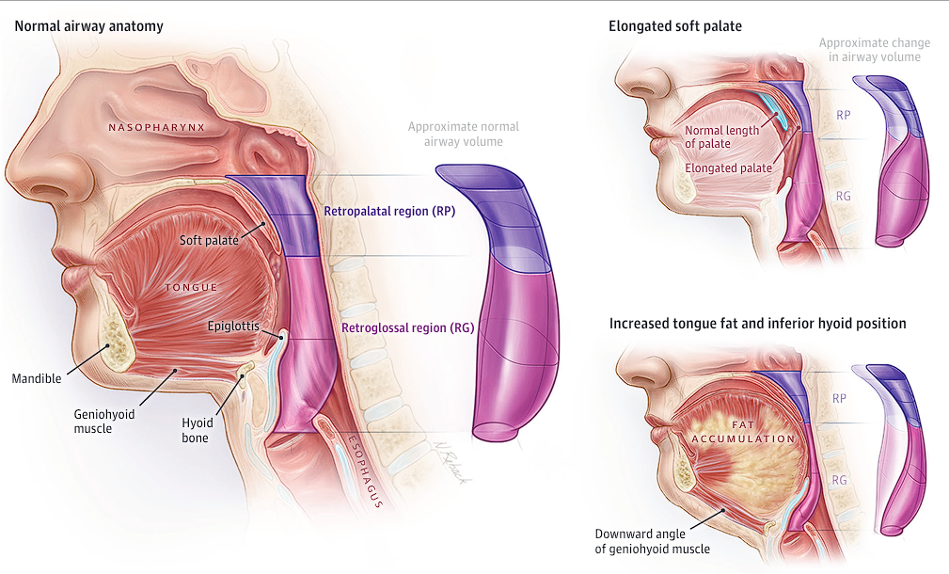

***Anatomic Features Contributing to Obstructive Sleep Apnea(OSA)***

**Why Finding a Solution for OSA is Critical**

Obstructive Sleep Apnea (OSA) is a serious condition that significantly increases the risk of hypertension, heart disease, stroke, and metabolic disorders like insulin resistance, type 2 diabetes, and obesity, all of which contribute to metabolic syndrome. The intermittent hypoxia in OSA promotes inflammation and worsens cardiovascular and metabolic health.

OSA also has a major impact on mental health, leading to depression, anxiety, and cognitive decline due to chronic sleep deprivation. In addition, excessive daytime sleepiness increases the risk of accidents, including fatal crashes and workplace errors, posing a serious safety risk.

The healthcare burden of untreated OSA is substantial, resulting in costly hospitalizations and long-term disease management. Early diagnosis and treatment, such as CPAP therapy and lifestyle changes, are crucial to prevent complications, improve quality of life, and reduce healthcare costs.

OSA is common in older adults but often undiagnosed due to overlapping symptoms with other age-related conditions. Treating OSA in the elderly is essential to prevent cognitive decline, cardiovascular issues, and maintain overall quality of life. Early intervention is key to reducing both the health and economic impact of OSA.

OSA is more than just a sleep disorder it’s a **silent killer** that demands immediate attention.

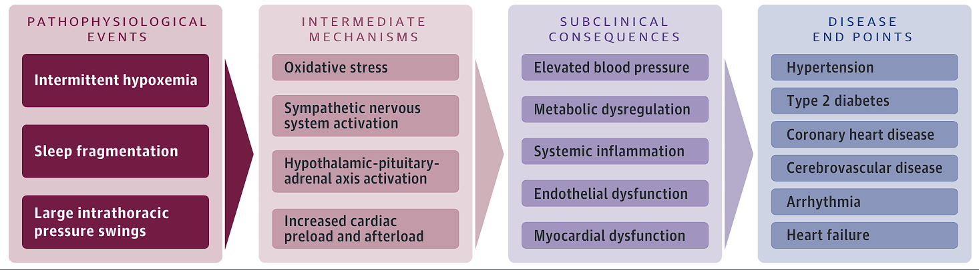

***Causal Mechanisms of Obstructive Sleep Apnea–Related Cardiovascular and Metabolic Disease***

**Standard Diagnostic Methods**

Diagnosing Obstructive Sleep Apnea (OSA) involves a combination of clinical evaluation, patient history, and specialized tests. The gold standard is **Polysomnography (PSG)**, an overnight sleep study that monitors brain activity, breathing patterns, and oxygen levels. For a more convenient option, **Home Sleep Apnea Testing (HSAT)** is used, where portable devices track airflow, respiratory effort, and oxygen saturation levels at home. Screening tools like the **STOP-BANG Questionnaire**, which assesses key risk factors such as snoring and daytime fatigue, and the **Epworth Sleepiness Scale (ESS)**, which measures daytime sleepiness, help identify those at risk. Early diagnosis is essential to prevent complications and improve treatment outcomes.

|  |  |  |  |  |
| --- | --- | --- | --- | --- |
| **Metric** | **Description** | **Additional Information** | **Sensitivity (%a)** | **Specificity (%a)** |
| **Berlin Questionnaire** | Eleven items grouped into 3 domains: snoring/apneas, fatigue/sleepiness, and obesity/hypertension. Range: 0-3; 0 indicates the lowest risk and 2-3 indicates high risk of OSA. | Developed for assessing sleep apnea risk in the primary care setting. | 77 (73-81) | 44 (38-51) |
| **STOP-Bang Questionnaire** | Eight items assess snoring, sleepiness, apneas, hypertension, obesity, neck girth, age, and sex. Range: 0-8; 0 indicates the lowest risk of OSA. | Developed for sleep apnea screening in the preoperative setting. | 90 (86-93) | 36 (29-44) |
| **Epworth Sleepiness Scale** | Self-administered assessment of sleep tendency in 8 common situations. Range: 0-24; 0 indicates the least sleepy, and greater than 10 indicates excessive sleepiness. | Widely used for assessing sleepiness and response of sleepiness to therapy; not useful in screening for OSA. | 47 (35-59) | 62 (56-68) |
| **Polysomnography** | Monitors EEG, eye movements, and chin muscle tone to assess sleep-wake state and thoracic/abdominal excursion, airflow, and pulse oximetry to identify apneas and hypopneas. | Criterion standard for diagnosis of OSA; also diagnoses other sleep disorders; high cost relative to HSAT. | - | - |
| **Home Sleep Apnea Testing (HSAT)** | Multiple available devices; most monitor airflow, respiratory effort, and oximetry; some use nonstandard measures like peripheral arterial tonometry. | Lower cost and greater convenience compared with polysomnography; false-negative results possible; unable to diagnose other sleep disorders. | 79 (71-86) | 79 (63-89) |
| **Oximetry** | Overnight recording of blood oxygen saturation. | Inexpensive and convenient; false-negative results possible; cannot distinguish OSA from central sleep apnea; can document resolution of hypoxemia with treatment. | 15-100 | 7-100 |

**Emerging methods**

While current diagnostic methods for Obstructive Sleep Apnea (OSA) are effective, they have several limitations. Polysomnography (PSG), the gold standard, provides high accuracy but is expensive, requires an overnight stay in a sleep lab, and often has long wait times. Home Sleep Apnea Testing (HSAT) offers a more convenient alternative but is less comprehensive, may underestimate severity, and is unsuitable for patients with complex conditions like heart or lung disease. Screening tools such as the STOP-BANG Questionnaire and the Epworth Sleepiness Scale (ESS) help assess risk but cannot confirm a diagnosis, as they rely on subjective responses and may misclassify certain individuals. Given these limitations, there is a growing need for better approaches, such as wearable technology and AI-driven analysis, which could improve accessibility and accuracy. Multi-night monitoring may also provide more reliable results compared to single-night testing. Further research is essential to develop cost-effective, at-home alternatives that match the accuracy of PSG while improving patient comfort and accessibility.

Machine learning models have proven to be highly effective in predicting AHI (Apnea-Hypopnea Index) with up to **90% accuracy**, making them a valuable tool for detecting sleep apnea early. By analyzing **personalised sleep position, snoring patterns** and other key indicators such as oxygen levels, heart rate variations, and breathing patterns, these models provide a fast, affordable, and convenient alternative to traditional sleep studies. With the integration of wearable devices like smartwatches and pulse oximeters, home-based monitoring has become more accessible, allowing individuals to track their sleep health without the need for complex or expensive medical tests. This advancement enhances early diagnosis and intervention, improving overall sleep health management.

**Early Symptoms**

Nighttime symptoms of sleep disorders often include **loud snoring**, which is often accompanied by pauses in breathing, followed by gasping or choking sensations. These pauses, known as apneas, can last from 10 to 30 seconds and may occur multiple times throughout the night. While the person affected may not be aware of these pauses, others might witness them. Additionally, the person may experience sudden awakenings from choking or gasping, which can cause a feeling of panic and oxygen deprivation. Sleep is often restless, with frequent tossing and turning, due to difficulty maintaining normal breathing patterns. This restless sleep can lead to waking up multiple times throughout the night, preventing restorative sleep.

During the daytime, individuals with sleep disorders may experience excessive daytime sleepiness (EDS), despite feeling as though they’ve had a full night of sleep. This is due to fragmented, non-restorative sleep. They may also suffer from morning headaches, which can be caused by oxygen level drops throughout the night. Difficulty concentrating and memory problems are common, with cognitive impairment that makes daily tasks more challenging. Additionally, emotional symptoms like irritability, moodiness, and even depression may arise due to chronic sleep deprivation. Another common symptom is waking up with a dry mouth or sore throat, often from mouth breathing during sleep, which is more common when nasal airflow is obstructed. Lastly, frequent nighttime urination (nocturia) may occur, as the body’s response to disrupted sleep and oxygen deprivation affects kidney function. These symptoms can significantly impact quality of life and may require medical evaluation and treatment.

|  |
| --- |
| **Risk factors that enhance the probability of OSA** |
| Obesity (BMI >30 kg/m2) |
| Neck circumference >40 cm |
| Male sex |
| Positive family history of OSA |
| Race (African American, Pacific Islander, and Mexican American) |
| Down syndrome |
| Marfan disease |
| Pierre-Robin syndrome |
| Age >40 y |
| Postmenopausal status |
| Alcohol ingestion before bedtime |
| Respiratory allergies and nasal congestion |
| Underlying hypertension |

**Dataset from Brighamand Womens Hospital**

The dataset involves patient health data focusing on sleep-related parameters and vital signs, primarily for analyzing sleep apnea and associated cardiovascular risks.

**Age** is a critical factor in health assessments, as older individuals are at higher risk for sleep apnea due to reduced muscle tone in the throat and increased fat deposits around the airway. It is also associated with higher blood pressure (BPsys/BPdia), increased apnea-hypopnea index (AHI), and greater oxygen desaturation (ODI).

**Sex (M/F)** plays a role in sleep apnea prevalence, with men being more prone to obstructive sleep apnea (OSA) due to anatomical differences, whereas women experience an increased risk post-menopause due to hormonal changes. Men typically have higher AHI, ODI, and BP than women. The dataset backs the claim as the following graph

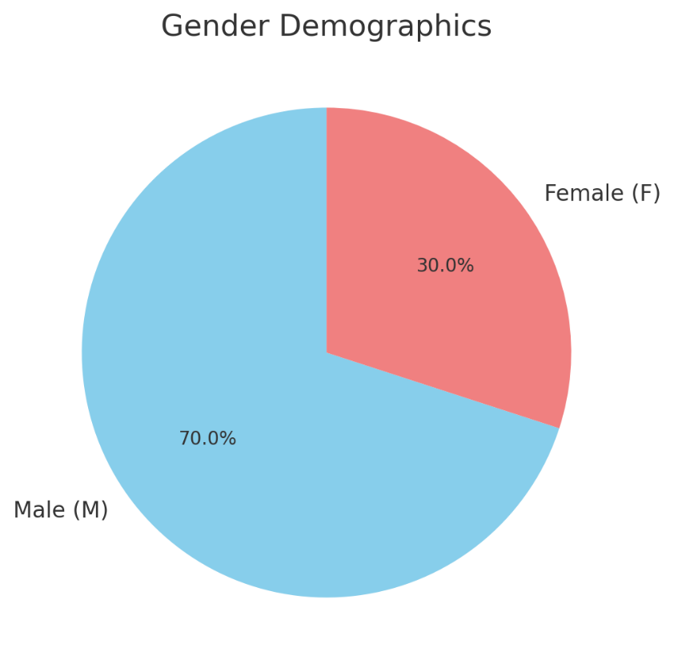

**Height and weight** are essential in determining body mass index (BMI), which directly correlates with sleep apnea severity. Higher weight, particularly obesity, leads to fat deposits around the airway, increasing the risk of airway collapse, which elevates the number of apnea (NAp) and hypopnea (NHyp) events.

**Pulse (heart rate in bpm)** is crucial as apnea episodes cause fluctuations in heart rate due to oxygen deprivation. When breathing resumes, the heart rate spikes, putting strain on the cardiovascular system.

**Blood pressure (BPsys/BPdia)** is significantly affected by sleep apnea. Frequent apnea episodes lead to stress responses in the body, causing elevated blood pressure, particularly nighttime hypertension, which does not respond well to standard treatments.

**Oxygen Desaturation Index (ODI)** measures how many times per hour blood oxygen levels drop significantly. Frequent desaturation events indicate poor oxygenation during sleep, leading to long-term health issues such as fatigue, cognitive impairment, and cardiovascular diseases. Higher ODI is strongly linked to more apnea (NAp) and hypopnea (NHyp) events, higher blood pressure, and greater heart rate variability.

**The number of apnea (NAp) and hypopnea (NHyp) events** recorded during sleep helps determine sleep apnea severity. Apnea refers to complete airway obstruction for at least 10 seconds, whereas hypopnea is a partial reduction in airflow by at least 30%, usually accompanied by oxygen desaturation or arousal from sleep. More NAp and NHyp events indicate increased AHI and ODI

**Understanding the Apnea-Hypopnea Index (AHI)**

AHI measures the number of apneas and hypopneas per hour of sleep and is used to diagnose sleep apnea severity.AHI is calculated through a sleep study, either using Polysomnography (PSG) or a Home Sleep Apnea Test (HSAT). During the study, apnea events—defined as pauses in breathing lasting **10 seconds or more**—and hypopnea events—characterized by a **30% or greater reduction in airflow with oxygen desaturation or arousal**—are identified. The total number of apneas and hypopneas is then summed.

***AHI Severity Index***

|  |  |  |  |
| --- | --- | --- | --- |
| **< 5** | **Normal** | **0–5%** | **No intervention needed** |
| **5–9** | **Mild (Low)** | **6–10%** | **Mild concern** |
| **10–14** | **Mild (High)** | **11–20%** | **Monitor closely** |
| **15–19** | **Moderate (Low)** | **21–30%** | **Moderate concern** |
| **20–24** | **Moderate (Mid)** | **31–40%** | **Serious concern** |
| **25–29** | **Moderate (High)** | **41–50%** | **Immediate intervention needed** |
| **30–39** | **Severe (Low)** | **51–78%** | **High concern** |
| **40–49** | **Severe (Mid)** | **79–98%** | **Critical concern** |
| **≥ 50** | **Critical (High)** | **100%+** | **Medical emergency** |

**Treatment methods**

**Weight Loss**  
Lifestyle interventions like diet and exercise can improve cardiovascular and metabolic health and are effective for OSA when combined with medication or bariatric surgery. However, weight loss can be challenging and time-consuming for many patients.

**Exercise (Aerobic)**  
Aerobic exercise aids weight loss and improves cardiovascular and metabolic health. However, it may be difficult for patients with musculoskeletal or cardiopulmonary issues to maintain.

**Sleep Position Restriction**  
Avoiding a supine sleep position with the help of pillows or devices can reduce OSA symptoms. It's cost-effective but only works for positional OSA and may be uncomfortable for some patients.

**Positive Airway Pressure (PAP)**  
PAP therapy uses pressure via a mask to improve sleep, quality of life, and blood pressure. It's effective for most patients, but one-third experience poor tolerance and side effects like nasal congestion and skin irritation.

**Mandibular Repositioning Devices (Oral Appliances)**  
These devices reposition the jaw during sleep, offering an alternative to PAP. They're well-tolerated by many but less effective for severe OSA or high obesity levels and may cause dental issues.

**Uvulopalatopharyngoplasty (UPPP)**  
This surgery removes the uvula and part of the soft palate to improve OSA. It’s effective but has lower efficacy than PAP, and may cause postoperative pain, with potential relapse and complications from weight gain.

**Maxillomandibular Advancement (MMA)**  
MMA involves surgical repositioning of the jaw for OSA. It's highly effective but requires a lengthy recovery (2–10 weeks) and can lead to complications like malocclusion and facial numbness.

**Tracheostomy**  
A rare, curative treatment for OSA, tracheostomy ensures therapy adherence but has cosmetic drawbacks and affects speech, requiring long-term care.

**Hypoglossal Nerve Stimulation**  
This surgery stimulates the hypoglossal nerve to prevent airway collapse. It's effective in select patients but costly and can cause temporary tongue weakness and discomfort.

**Conclusion**

OSA is common, and its prevalence is increasing. Daytime sleepiness is among the most common symptoms, but many patients with OSA are asymptomatic. Patients with OSA who are asymptomatic or have minimal symptoms that do not pose an apparent risk to driving safety can be managed with behavioural measures such as weight loss and exercise. Interventions such as PAP therapy are recommended for those with excessive sleepiness and resistant hypertension. Advancements in AI, wearable technology, and big data analytics are paving the way for more accurate and efficient sleep disorder diagnosis.

**Articles Referred:**

Gottlieb, D. J., & Punjabi, N. M. (2020). *Diagnosis and Management of Obstructive Sleep Apnea. JAMA, 323(14), 1389.* doi:10.1001/jama.2020.3514

https://jamanetwork.com/journals/jama/fullarticle/2764461

Alapati R, Renslo B, Jackson L, Moradi H, Oliver JR, Chowdhury M, Vyas T, Bon Nieves A, Lawrence A, Wagoner SF, Rouse D, Larsen CG, Wang G, Bur AM. <https://pubmed.ncbi.nlm.nih.gov/38232604/>

S. R. Veasey, MD; R. J. Rosen, MD *Journal:* Journal of Allergy and Clinical Immunology <https://www.jacionline.org/article/S0091-6749%2803%2902186-9/abstract?utm_source=chatgpt.com>

Courtesy: **Brighamand Womens Hospital for dataset**